SEEM

(SIMPLE ESTUARINE EUTROPHICATION MODEL)

USER’S MANUAL.

John Parslow, Adam Davidson, John Hunter.

CSIRO Marine Research
Hobart, Tasmania


TABLE OF CONTENTS

INTRODUCTION. 2
MODEL DESCRIPTION. 2
PHYSICAL PROCESSES. 2
BIOGEOCHEMICAL MODULE. 4
MODEL PARAMETERS. 7
FORCING. 8
Boundary Conditions. 8
Loads. 8
RUNNING THE MODEL. 8
THE INPUT FILES. 8
Geometry File. 8
Master Parameter File For INVERSE. 11
Biogeochemical Parameter File. 13
Riverflows. 14
Boundary Files. 15
Light 15
Loads. 16
State Initialisation and Output Files. 17
USING SEEM. 19
RUN MANAGEMENT. 19
SPECIFYING A RUN. 20
Files. 20
Run-Time Parameters 21
Description. 22
RUNNING THE MODEL. 22
GRAPHICAL DISPLAY. 23
REFERENCES 24

INTRODUCTION.

SEEM (Simple Estuarine Eutrophication Model) is a software toolkit which provides the user with a basic capability to model nitrogen cycling and algal biomass in estuaries in response to nitrogen loads. The toolkit is designed to make model implementation, analysis and calibration as simple as possible. SEEM is intended to provide synthesis and interpretation of field data for scientists, and as a decision support tool for environmental managers. A detailed explanation of the principles underlying SEEM, and example applications to three test cases, are given in Parslow et al (1999).

The toolkit consists of two principal modules and some auxiliary tools.
- The biogeochemical model (SEEM.BAT) is implemented in JAVA and integrated within a graphical user interface which provides run management, and graphical display of output.
- The physical exchanges to drive the model are estimated from observed salinity fields, using an inverse package implemented in FORTRAN, and supplied as a WIN-32 executable (INVERSE.EXE) which can be run from a command prompt INVERSE.BAT.
- The state variable input and output files are written as random-access binary files, to allow for hot starts from previous runs. These can be converted to and from ASCII files, to make the data easily accessible by text editors or other analysis packages, using STATEGEN.BAT (ASCII to binary) and STATEDUMP.BAT (binary to ASCII).

MODEL DESCRIPTION.

PHYSICAL PROCESSES.

The physical transport model underlying SEEM is an n-layer hybrid model (Parslow et al, 1999, Section 5). This provides a 2-D vertical description of the estuary, and divides the estuary length-wise into m columns, and vertically into n layers. The cell in column i and layer j is referred to as cell_{i}^{j}. There can in principle be any number of columns and layers, from 1 up. To date, SEEM has been applied to test cases with 1 layer (well-mixed estuary) or 2 layers (stratified or partially-stratified estuaries).

In the numbering convention used in SEEM, the first column is column 0, and the first layer is layer 0. Layers are numbered from bottom to top, so that the bottom layer is layer 0.

SEEM allows for vertical and horizontal two-way exchanges, representing both advection and diffusion (Fig. 1). These exchanges are specified as volume exchanges (m³ s⁻¹). The exchanges at any given river flow are estimated by linear interpolation on a set of reference exchanges, calculated at reference riverflows (Parslow et al, 1999, Section 5). This table of reference river flows and exchanges must be provided to SEEM as an input file.

Fig. 1. Exchanges in n-layer hybrid model.

The reference exchanges are calculated separately, using a robust inverse technique, from observed salinity fields (Parslow et al, 1999, Section 5). The inverse model (INVERSE.BAT) must be supplied with the estuary geometry, a set of observed river flows and corresponding salinities in each cell, and controlling parameters discussed below. It then produces an output ASCII file which can be used as an input file to SEEM.

SEEM is implemented as a dynamical model. The user provides a time series of river flows. The model river flow at any given time step is calculated from this time series by linear interpolation, and the corresponding physical exchanges calculated by linear interpolation on the reference riverflows and exchanges. Note that the riverflows provided as a time series should fall within the range of reference riverflows. If riverflows are specified which fall outside the range of reference riverflows, SEEM uses the exchanges corresponding to the minimum or maximum reference flow, as appropriate.

The SEEM geometry specifies the length of each column (l), the depth (thickness) H of each cell, and the plan area A of the top of each cell. For cells other than the bottom cell, the volume is calculated as the product of depth times the mean of top and bottom plan areas:

V_{i}^{j} = H_{i}^{j} . (A_{i}^{j} + A_{i-1}^{j}) / 2.

The depth specified for cells in the bottom layer is the maximum depth, and a shape factor SF is specified, so that the volume is calculated as

V_{i}⁰ = H_{i}⁰ . SF_{i}⁰ . A_{i}⁰.

As well as horizontal and vertical transport of dissolved tracers, SEEM allows for sinking and resuspension of particulate tracers. SEEM does not include an explicit bottom sediment layer, but instead represents an implicit sediment pool, by calculating a suspended fraction (0 to 1), for each tracer. The user specifies a sinking rate w (m d⁻¹) for each particulate constituent, and a resuspension rate RESUSP with units of d⁻¹ for bottom sediments in each cell.

For cells other than bottom cells, the bottom sediment area is equal to A_{j} – A_{j-1}. The suspended fraction in these cells is given by

σ_{i}^{j} = RESUSP_{i}^{j} . V_{i}^{j} / (RESUSP_{i}^{j} .V_{i}^{j} + w . (A_{i}^{j} – A_{i}^{j-1}) ).

The suspended fraction in the bottom cell is:

σ_{i}⁰ = RESUSP_{i}⁰ . V_{i}⁰ / (RESUSP_{i}⁰ .V_{i}⁰ + w . A_{i}⁰).

Only the suspended part of any tracer, σ_{i}^{j} . C_{i}^{j}, is subject to horizontal and vertical exchange within the water column. For example, the tracer flux associated with horizontal volume flux q_{i,i+1}^{j} is given by q_{i,i+1}^{j} . σ_{i}^{j} . C_{i}^{j}. For cells other than bottom cells, the sinking flux of tracer C from cell j to cell j-1 is given by
w . σ_{i}^{j} . C_{i}^{j} .A_{i}^{j-1}.

The physical exchanges (and biogeochemical changes) are implemented using a simple forward difference scheme. In order to reduce the risk of numerical instabilities, the inverse scheme is run with upstream differencing implemented, so that all volume exchanges are positive (Parslow et al, 1999, Section 5). At least with respect to transport, the model will run stably and with reasonable accuracy provided the time step δt is kept sufficiently small that

max _{i,k}^{j} ( q_{i,k}^{j} . δt / V_{i}^{j}) << 1.

As well as the biogeochemical state variables, SEEM calculates salinity (SAL) as a diagnostic tracer.

BIOGEOCHEMICAL MODULE.

A detailed derivation and analysis of the biogeochemical model can be found in Parslow et al (1999). The biogeochemical model includes 4 state variables: phytoplankton biomass (PHY), DIN, labile organic detritus (DET) and refractory organic detritus (DON). Depending on the assigned sinking rates, DET and DON can be treated as particulate or dissolved. While the refractory pool is often treated as a dissolved pool, it is more appropriate to refer to it as refractory, and it is denoted by REF in Parslow et al (1999). In comparing this report with Parslow et al (1999), DON and REF should be treated as equivalent. In the following equations, all variables are defined in nitrogen equivalent concentrations as mg N m⁻³ and all rates of change as mg N m⁻³ d⁻¹.

Note that it is conventional to express rates as d⁻¹ for most biological parameters, while physical models normally use s⁻¹. We define the biogeochemical model, and more importantly to the user, the biogeochemical rate parameters, in units of d⁻¹. However, SEEM works internally in units of seconds, and converts all rate parameters to units of s⁻¹ automatically.

The dynamical equations defining the model are:

dDIN/dt = - μ.PHY + (1-FGDET).m.PHY + (1-E_{DEN}).R_{SED} + R_{W}
dPHY/dt = μ.PHY – m.PHY

dDET/dt = FGDET.m.PHY – RDET . DET

dDON/dt = FDETDON . RDET . DET – RDON . DON

Here, μ is the phytoplankton growth rate, m the phytoplankton loss rate, FDET the proportion of phytoplankton loss assigned to DET, R_{SED} is the sediment respiration rate, E_{DEN} the denitrification efficiency, and R_{W} is the water column respiration rate. In Eq 3 and 4, RDET and RDON are the breakdown rates of labile and refractory detritus, and FDETDON is the proportion of labile detritus converted to refractory detritus.

The phytoplankton growth rate is given by:

μ = μmax.h_{N}.h_{I},

where

h_{N} = DIN / (KN + DIN).

and

h_{I} = (1. – exp(-<I>_{i}^{j} . KI)).

where KI is the saturation light intensity. The mean light intensity <I>_{i}^{j} in cell _{i}^{j} is given by:

<I> _{i}^{j} = (I _{i}^{j} – I _{i}^{j-1}) / (K.H_{i}^{j}),

where I _{i}^{j} is the light intensity at the top of cell_{i}^{j}, and K is the diffuse attenuation coefficient. I_{i}^{j} is computed by:

I _{I}^{j-1} = I_{i}^{j}. exp(-K.H _{i}^{j}).

The user specifies the surface light intensity I₀ (W m⁻², average daily PAR), so that, if the model has n layers,

I_{i}^{n-1} = I₀.

The light attenuation coefficient K is given by:

K = K0 + KPHY . PHY + KDET . DET + KDON . DON,

where K0 represents background light attenuation (m-1), and KPHY, KDET and KDON are specific light attenuation coefficients (m2 (mg N)-1).

The phytoplankton mortality rate is given by

m(PHY) = m0 + 4.m1.PHY/(PM + PHY)² 4.8

and has a maximum value m0+m1 at PHY = PM. The sediment respiration rate is given by:

R_{SED} = RDET.(1-σ_{DET}).DET.(1-FDETDON) + RDON.(1-σ_{DON}).DON 4.9

and the water column respiration rate is given by

R_{W} = RDET.σ_{DET}.DET . (1-FDETDON) + RDON.σ_{DON}.DON. 4.10

The denitrification efficiency E_{DEN} is given by

E_{DEN} = EFFDENMAX . (1 – R_{SED} / RSED0). 4.11

and RSED0 = RSED0* / H, where RSED0* has units of mg N m⁻² d⁻¹.

MODEL PARAMETERS.

A list of the model biogeochemical parameters is given in Table 1. The nomenclature in the current SEEM model described above, and in Parslow et al (1999), differ. The equivalent parameter names in Parslow et al (1999) are given in Table 1.

SEEM symbol | Description | Units | Symbol in  Parslow et al (1999)
P_MUMAX | Maximum phytoplankton growth rate | d⁻¹ | μmax
P_KN | Half-saturation constant for phytoplankton growth on DIN | mg N m⁻³ | K_{N}
P_KI | Light saturation intensity | W m⁻² | I_{K}
P_M0 | Background constant phytoplankton loss rate | d⁻¹ | m₀
P_M1 | Maximum grazing loss rate | d⁻¹ | m₁
P_PM | Phytoplankton biomass corresponding to maximum grazing loss rate | mg N m⁻³ | K_{P}
P_FGDET | Fraction of grazing losses to labile detritus |  | f_{DET}
P_FDETDON | Fraction of labile detritus to refractory detritus |  | f_{REF}
P_RDET | Breakdown rate of labile detritus | d⁻¹ | r_{DET}
P_RDON | Breakdown rate of refractory detritus | d⁻¹ | r_{REF}
P_EFFDEN_MAX | Maximum denitrification efficiency |  | E_{DEN}^{max}
P_RSED0 | Sediment respiration rate at which E_{DEN} = 0. | mg N m⁻² d⁻¹ | R₀
P_K0 | Background light attenuation | m⁻¹ | K₀
P_KPHY | Specific light attenuation for phytoplankton | m² (mg N)⁻¹ | k*_{PHY}
P_KDET | Specific light attenuation for labile detritus. | m² (mg N)⁻¹ | k*_{DET}
P_KDON | Specific light attenuation for refractory organic N | m² (mg N)⁻¹ | k*_{REF}
SINK.PHY | Sinking rate of phytoplankton | m d⁻¹ | w_{PHY}
SINK.DET | Sinking rate of labile detritus | m d⁻¹ | w_{DET}
SINK.DON | Sinking rate of refractory organic N | m d⁻¹ | w_{REF}
SINK.DIN | Sinking rate of DIN | m d⁻¹ | w_{DIN}
Table 1. Model biogeochgemical parameters.

FORCING.

As well as the reference exchanges and time series of riverflows, the model also requires specification of other forcing data.

Boundary Conditions.

The downstream column (m-1) is specified as an ocean boundary column. The state variable concentrations in all cells in this column must be specified as time series files (see below).

Loads.

Loads of all state variables can be specified for any cell. A master list of loads specifies the time series file for each source, and the cell (ie column and layer) into which it discharges. The individual loads are then specified as time series files (see below). Loads of each constituent are specified as mg N s-1.

Note that the physical transport model assumes that the river discharges into the top layer in column 0, and river loads should also be specified as discharging into this cell. If the model specifies 2 or more layers, and the river flow is sufficiently strong that both top and bottom cells in column 0 are fresh, the physical exchanges will specify a direct vertical advective flux of fresh water (and associated loads) from the top to the bottom cell in column 0.

RUNNING THE MODEL.

THE INPUT FILES.

This section specifies the input files needed to run both the inverse model and the SEEM model itself.

Geometry File.

Sample geometry files for 1 and 2 layer systems are given in Boxes 1 and 2. Note that
- Comments are preceded by a “#” and ignored by the input routines.
- Data are preceded by “VARNAME =”, where VARNAME is a prescribed variable name which the input file must find in order to read the corresponding data successfully. Because the input file searches by name, the order in which variables are specified is unimportant.
- Variable values which are prescribed for each cell are placed in order, from column 0 to n-1, on one line. These values can be separated either by spaces or TABS.
- The values for each layer are placed on separate lines. The naming convention for variable VAR for layer k is LAYERk.VAR = …
- For cells which are not boundary cells, LAYERk.BOUNDARY = NONE. For boundary cells, LAYERk.BOUNDARY specifies the full path to the time series file specifying boundary concentrations (see below). Note that the JAVA input routine requires that the normal “\” be replaced by “\\” in the path specification.

In each new application, the geometry file, and other ASCII input files, can be created quickly by using an existing file as a prototype, and replacing data values.

# Number of Columns
NCOLS = 5
# Number of Layers
NLAYERS = 1

#
# Sample 1 layer geometry
#
#
# Column lengths (m):
COLLENGTH = 750 750 1000 900 1000

# Plan areas (m2):
LAYER0.AREA = 28125 37500 50000 45000 50000

# Depths (m):
LAYER0.DEPTH = 1.8 2 2.3 2.8 2.8

#Shape factor
LAYER0.SHAPE = 0.81 0.59 0.34 0.24 0.38

#Resuspension rates (d-1)
LAYER0.RESUSP = 0.1 0.1 0.1 0.1 0.1

#Boundary source files.
LAYER0.BOUNDARY = NONE NONE NONE NONE C:\\...\\bound0.ts

Box 1. Sample geometry file for 1 layer system.

# Number of columns
NCOLS = 5
# Number of Layers
NLAYERS = 2

#
# Sample 2-layer Geometry
#
#
# Column lengths (m):
COLLENGTH = 4000 3000 800 1500 1700

# Plan areas (m2):
LAYER0.AREA = 1080000 1800000 432000 660000 489600
LAYER1.AREA = 1568000 6411000 600000 975000 663000

# Depths (m):
LAYER0.DEPTH = 6 1.5 4 1.5 1.5
LAYER1.DEPTH = 1 1 1 1 1

# Shape factor
LAYER0.SHAPE = 0.24 0.53 0.38 0.77 0.61

# Resuspension rate (d-1)
LAYER0.RESUSP = 0.1 0.1 0.1 0.1 0.1
LAYER1.RESUSP = 0.1 0.1 0.1 0.1 0.1

LAYER0.BOUNDARY = NONE NONE NONE NONE c:\\...\\bound0.ts
LAYER1.BOUNDARY = NONE NONE NONE NONE c:\\...\\bound1.ts

Box 2. Sample geometry file for 2-layer model.
Salinity file.

The same geometry file is used by both SEEM and INVERSE. INVERSE also requires a file containing river flows and corresponding salinities. An example input salinity file is shown in Box 3. Note that the same conventions about comments, names and data values apply as for geometry. The number of reference salinity surveys is specified as NRIVERFLOWS = . The riverflows are numbered sequentially, starting at 0, and specified as RIVERFLOWx. The corresponding salinities are then named RIVERFLOWx.LAYERk.SAL.

#
# Sample salinity data set.
#
# Number of flow scenarios:
NRIVERFLOWS = 3
#
# River flow (m3 s-1):
RIVERFLOW0 = 0.67
#
# Salinity data:
RIVERFLOW0.LAYER0.SAL = 33.5 24.5 34.3 35.3 35.4
#
RIVERFLOW0.LAYER1.SAL = 18.1 22.0 28.5 28.5 31.5
#
# River flow (m3 s-1):
RIVERFLOW1 = 88.3
#
# Salinity data:
RIVERFLOW1.LAYER0.SAL = 1.8 1.8 16.4 32.5 33.0
#
RIVERFLOW1.LAYER1.SAL = 1.6 1.8 2.0 1.8 2
#
# River flow (m3 s-1):
RIVERFLOW2 = 0.58
#
# Salinity data:
RIVERFLOW2.LAYER0.SAL = 30.6 32.2 33.8 36.2 36.3
#
RIVERFLOW2.LAYER1.SAL = 27.5 32.2 31.8 36.2 36.3
#
Box 3. Sample salinity file for input to INVERSE.

Master Parameter File For INVERSE.

The master parameter file for the INVERSE routine specifies where to find the geometry and salinity files. It also specifies other parameters which control the behaviour of INVERSE. An example is given in BOX 4.
- As this is a FORTRAN routine, the path must be specified with a single backslash.
# Sample parameter file for INVERSE
#
# Salinity filename:
SALINITYFILE = C:\...\hardy2.sal
#
# Geometry filename:
GEOMETRYFILE = C:\...\geoms.txt
#
# Diagnostic option:
DIAG = f
#
# Minimal upstream differencing option:
UPSTREAM = t
#
# Spatial weighting option:
SPATIALWEIGHTS = t
#
# Number of columns:
NCOLS = 5
#
# Number of layers:
NLAYERS = 2
#
# Relative weighting for vertical fluxes:
VERT_WT = 1.
#
# Relative weighting for salt conservation equation:
SALT_WT = 0.03
#
# Minimum allowable proportional error:
MIN_PROP_ERROR = .0000000001
#
# Maximum allowable proportional error for truncation:
MAX_PROP_ERROR = .000000001
Box 4. Sample master parameter file for INVERSE.
- DIAG = f results in an output file containing only exchanges, suitable for input to SEEM. DIAG = t results in a full suite of information on the performance of the inverse model.
- UPSTREAM = t ensures that all exchanges are positive (see Parslow et al, 1999). This option must be selected if exchanges are to be used in SEEM.
- SPATIALWEIGHTS = t restricts the variability of the velocity in the vertical, while SPATIALWEIGHTS = f restricts the variability of the flux in the vertical. For general use, it is recommended that SPATIALWEIGHTS = t is used.
- VERT_WT = 1. applies equal weighting to the horizontal and vertical fluxes. This is probably the best general choice. However, in estuaries where the vertical fluxes are deemed to be significantly larger than the horizontal fluxes (as would be the case if the horizontal dimension of each column was particularly large) it is best to choose a value of VERT_WT greater than unity. Similarly, where the vertical fluxes are deemed to be significantly smaller than the horizontal fluxes it is best to choose a value of VERT_WT less than unity. In general, the model tends to make the ratio of vertical to horizontal fluxes equal to the value of VERT_WT.
- SALT_WT = 0.03 applies less weighting to the salt conservation equations than to the water conservation equations (by a factor of 0.03, which is approximately equal to the inverse of the salinity). The exact value of this parameter is not critical and it should generally be set at 0.03.
- MIN_PROP_ERROR = .0000000001 simply determines the minimum solution error displayed when the DIAG = t option is used. It has no effect on the computation of the fluxes.
- MAX_PROP_ERROR = .000000001 determines the maximum allowable proportional error in the conservation equations. This value affects the level of truncation applied after singular value decomposition and should not be changed.
- The file specifies the number of columns and number of layers, and INVERSE checks that these are compatible with the geometry and salinity files.

Biogeochemical Parameter File.

The biogeochemical parameter files are managed by SEEM, and the user normally views and edits these through the SEEM user interface. SEEM automatically writes a new parameter file each time the parameters are changed. Because the parameter full names and properties are carried by SEEM, the parameter file does not include descriptions or units. Box 5 shows a sample parameter file output by SEEM. Note that the order of parameters is not important, but that the names used by SEEM must be correctly specified. Each name is preceded by “P_”.

#Biology Parameter File. Generated by SEEM.
#Thu Jun 04 02:07:25 GMT 1998
P_KDET=0.0035
P_EFFDEN_MAX=0.6
P_PM=20
SINK.PHY=0
SINK.SAL=0
P_K0=0.05
P_KPHY=0.0035
P_MUMAX=2.0
SINK.DON=0
P_FGDET=0.5
P_RDET=0.1
P_KDON=0.0009
P_M1=0.6
P_M0=0.1
SINK.DIN=0
P_RSED0=250
P_RDON=0.01
P_KN=10
P_KI=10
P_FDETDON=0.1
SINK.DET=1.0

Box 5. SEEM Biology Parameter File.

Riverflows.

The Riverflow file is one of a series of files which specify time series of inputs or boundary conditions for SEEM. These files are all ASCII files, written using a standard time series format. A sample riverflow file is given in Box 6.

## SAMPLE RIVER FLOW FILE
##
## COLUMNS 2
##
## COLUMN1.long_name Time
## COLUMN1.name time
## COLUMN1.units seconds since 1990-01-01 00:00:00
##
## COLUMN2.name RIVERFLOWS
## COLUMN2.long_name RIVERFLOWS
## COLUMN2.units m3 per second
##
- 80
500000 120
1200000 60
Box 6. Sample riverflow file.

Note that the file consists of a header (header lines start with ##), followed by lines of data. The first data column is time, given as seconds since a specified epoch. The second column in this case is riverflow. The header specifies the number of columns, and the names and units of the columns. The time series input routine parses the header, looking for the specified variable names, and then reads the data, one time per line. The time series routines can recognise different units of time eg seconds or days, and adjust accordingly.

The time series routines also provide automatic linear interpolation in time inside the model. Thus, the riverflow at time 100000 seconds is automatically obtained by linearly interpolating between 0 and 500000 seconds. The time series routines also automatically extrapolate outside the specified range of times. Thus, in this example, if the model requires riverflow at times before 1990-01-01 00:00:00 + 0 seconds, the time series returns the value 80. If the model requires riverflows at times after 1990-01-01 00:00;00 + 1200000 seconds, the time series returns the value 60. This means that one can prescribe a constant value for any time series by providing one value at any arbitrary time.

Note that the model runs internally on absolute time, determined by the specified epoch. An epoch must be specified in both input time series and the model run time parameter file (see below), and care must be taken that these are consistent.

Boundary Files.

A boundary time series file must be prepared for each boundary cell, specifying the concentrations of all state variables (PHY, DIN, DON, DET and SAL) over time. In a 2 layer model, separate time series files must be prepared for top and bottom cells in the boundary column. In the example given (Box 7), constant boundary concentrations are specified for all tracers.

##
## COLUMNS 6
##
## COLUMN1.long_name Time
## COLUMN1.name time
## COLUMN1.units seconds since 1990-01-01 00:00:00
##
## COLUMN2.name PHY
## COLUMN2.units mg N m-3
##
## COLUMN3.name DIN
## COLUMN3.units mg N m-3
##
## COLUMN4.name DON
## COLUMN4.units mg N m-3
##
## COLUMN5.name DET
## COLUMN5.units mg N m-3
##
## COLUMN6.name SAL
##
0.0 5 10 100 10 35
Box 7. Sample boundary time series file.

Light
Surface light intensity (PAR, W m⁻² averaged over 24 hours) is also specified as a time series file in the same format. An example is shown in BOX 8.

##
## COLUMNS 2
##
## COLUMN1.long_name Time
## COLUMN1.name time
## COLUMN1.units seconds since 1990-01-01 00:00:00
##
## COLUMN2.name LIGHT
## COLUMN2.units W m-2 (PAR)
##
0.0 200
Box 8. Sample surface light intensity time series file.

Loads.

The master load file specifies the location and source files for all model loads. An example is given in Box 9.

## Load specification for cells.
## The file has the format:
## LOADN = file column layer
## Note that column and layer indices start from 0.

NLOADS = 4

LOAD1 = c:\\...\\loadrivsep.txt 0 0
LOAD2 = c:\\...\\loadMull.txt 3 0
LOAD3 = c:\\...\\loadOS.txt 9 0
LOAD4 = c:\\...\\ loadBrun.txt 12 0
Box 9. Sample master load file.

Note that the JAVA \\ convention for path specification must be followed.

Each load is specified using a separate time series file. An example is shown in Box 10, again for constant load over time. Note that the salinity load is not specified. The model assumes loads of any variables not included are zero.

##
## COLUMNS 5
##
## COLUMN1.long_name Time
## COLUMN1.name time
## COLUMN1.units seconds since 1990-01-01 00:00:00
##
## COLUMN2.name PHY
## COLUMN2.units mg N s-1
##
## COLUMN3.name DIN
## COLUMN3.units mg N s-1
##
## COLUMN4.name DON
## COLUMN4.units mg N s-1
##
## COLUMN5.name DET
## COLUMN5.units mg N s-1
##
0.0 0.0 48.4 0. 15.
Box 10. Sample load time series file.

State Initialisation and Output Files.

SEEM reads and writes time series of model states in binary form. The model will accept a previous output file as an initialisation file, along with a specified start time, and automatically adopt the state at the specified time as its initial state. This allows for easy hot-starting or restarting from previous runs. The model uses the standard time series conventions discussed above. In particular, if the nominated start time lies before any times in the nominated initialisation file, it will take the earliest state in that file as its initial state. If the initial file contains only one time and corresponding state, the model will adopt that state as its initial state, regardless of start time.

In order to prepare an initial state file from scratch, and to allow the user to translate output binary files into ASCII form for inspection or analysis, the toolkit also uses an ASCII time series convention for model states. This convention represents a combination of the time series convention and model geometry convention described above. When an ASCII initial file is created, it is converted to binary by running the DOS executable STATEGEN with input and output files as arguments (eg):

STATEGEN state.txt state.bin.

Once a binary model output file has been created, it is converted to ASCII by running the DOS executable STATEDUMP eg

STATEDUMP output.bin output.txt.

EPOCH = seconds since 1990-01-01 0:00:00
NCOLS = 5
NLAYERS = 2
NVARS = 5
VARNAMES = PHY DIN DON DET SAL
NTIMES = 1
TIME0.TIME = 0
TIME0.LAYER0.PHY = 5 5 5 5 5
TIME0.LAYER0.DIN = 10 10 10 10 10
TIME0.LAYER0.DON = 100 100 100 100 100
TIME0.LAYER0.DET = 10 10 10 10 10

TIME0.LAYER1.PHY = 10 10 10 10 10
TIME0.LAYER1.DIN = 10 10 10 10 10
TIME0.LAYER1.DON = 100 100 100 100 100
TIME0.LAYER1.DET = 10 10 10 10 10

TIME0.LAYER0.SAL = 20 30 30 30 30
TIME0.LAYER1.SAL = 10 15 20 25 30
Box. 11. Example of a user-prepared state initialisation file.

An example of an ASCII initial file is shown in Box 11. Note that:
- The epoch must be given to fix absolute time.
- The number of columns, layers and variables must be correctly specified.
- The number of times must be given.
- Times are numbered, starting from zero.
- The convention for state variables is the same as for geometry ie one variable-layer per line.
- The naming convention for times, layers and variables must be adhered to.

An example of part of a SEEM output file converted to ASCII is shown in Box 12. It has essentially the same format as the user-prepared initial file, but includes the location of the corresponding geometry file. Note that state variable values are output in double precision to allow accurate restarts.

## ASCII state file. Generated by SEEM.
GEOMETRY.FILE = C:\...\geoms.txt
EPOCH = day since 1990-01-01 00:00:00
NCOLS = 5
NLAYERS = 2
NVARS = 5
VARNAMES = PHY DIN DON DET SAL
NTIMES = 41
TIME0.TIME = 0.0
TIME0.LAYER0.PHY = 5.0 5.0 5.0 5.0 5.0
TIME0.LAYER1.PHY = 10.0 10.0 10.0 10.0 10.0
TIME0.LAYER0.DIN = 10.0 10.0 10.0 10.0 10.0
TIME0.LAYER1.DIN = 10.0 10.0 10.0 10.0 10.0
TIME0.LAYER0.DON = 100.0 100.0 100.0 100.0 100.0
TIME0.LAYER1.DON = 100.0 100.0 100.0 100.0 100.0
TIME0.LAYER0.DET = 10.0 10.0 10.0 10.0 10.0
TIME0.LAYER1.DET = 10.0 10.0 10.0 10.0 10.0
TIME0.LAYER0.SAL = 20.0 30.0 30.0 30.0 30.0
TIME0.LAYER1.SAL = 10.0 15.0 20.0 25.0 30.0
TIME1.TIME = 0.9953703703703703
TIME1.LAYER0.PHY = 4.038313466013453 4.5753385540658975 3.973749814138245 3.759282462116878 1.4
TIME1.LAYER1.PHY = 9.039168861216853 9.119048516956193 7.600733873738154 8.795983079573107 2.5
. . . . . .

Box 12. Part of output ASCII file.

USING SEEM.

The user runs SEEM through a graphical user interface shown in Fig. 2. The interface is divided into three panels: the left panel provides run management and access to all previous runs; the central panel allows the user to select and edit parameters and files to specify the current run, while the right panel controls the graphical display.

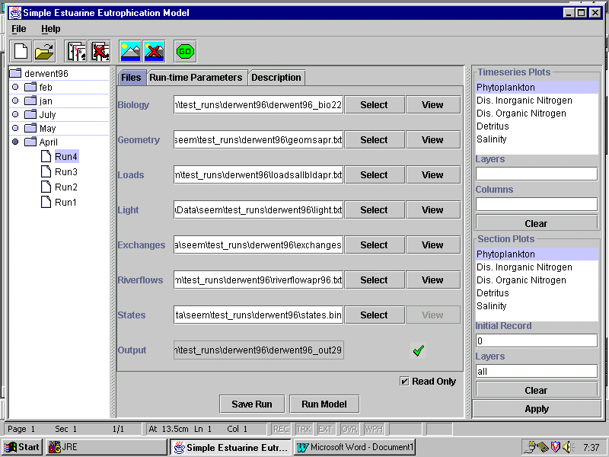
Fig. 2. SEEM Model User Interface.

RUN MANAGEMENT.

SEEM provides a hierarchical run management environment. A complete set of runs (eg for a particular estuary) is recorded in a run library (here derwent 96.lib). Within that set, closely related runs are grouped into scenarios. In this case, all the runs corresponding to each field survey are grouped together into feb, jan, July, May, April scenarios. By clicking on the File button, or the open folder symbol below File, the user can either open an existing library or start a new library. When the library is opened, the set of existing scenarios is displayed. By clicking on any scenario, the user can see the list of existing runs. These are automatically numbered Run1 Run2 etc by SEEM as they are created.

If the user clicks on an existing Run, the specifications for that run appear in the central panel. The user can create a new run based on the currently selected run by clicking on the run (playing cards icon) button above. Alternatively, the user can delete the selected run, by clicking on the delete run (crossed playing cards) icon. The user can create a new scenario by clicking on the scenario (scenery) icon above, and delete a current scenario by clicking on the delete scenario (crossed scenery) icon.

For each run, the library and scenario files automatically keep track of the list of input and parameter files in the central panel, which, along with the run-time parameters (see below), specify the run completely. In deciding when to create a new run library, and when to create a new scenario, we recommend:
- If the geometry is changed substantially (ie a new estuary) create a new library.
- If the forcing files (loads, etc) change substantially, create a new scenario.
- Use runs within a scenario to experiment with different model parameter sets.
We also recommend that the user create a new subdirectory for each library, and new sub-subdirectories for the forcing files for each scenario. The parameter files and output files will automatically be written into the library directory (see below).

SPECIFYING A RUN.

The central panel has three panes, Files, Run-Time Parameters, Description, selected by the tabs along the top of the panel.

Files.

The Files pane shown in Fig. 2 specifies all the input and output files. These are, from top to bottom, the Biology (biogeochemical parameter) file, the Geometry file, the (Master) Loads file, the Light time series file, the Exchanges file from the transport model, the Riverflows time series, the initial States file, and the Output file. The input files are all selectable, through a standard pop-up file selection interface, and the ASCII files (ie all but the binary initial state and output files), are viewable. The biogeochemical parameter and geometry files are viewed as JAVA tables (see below) while the other ASCII files are viewed simply as text.

In Fig. 2, there is a large tick next to the output file, indicating that the run has been completed and the output file exists. There is also a small enclosed tick marked Read Only, indicating that the user’s ability to edit the biology and geometry files is disabled (these are marked as VIEW above). Clicking on this tick will re-enable the edit facility on these files, with a warning that this may affect other runs (see below).

When a new run is created in the file management panel, the central panel looks essentially identical to Fig. 2, except that Edit rather than View appears next to the Biology and Geometry files. When a new run is created based on an existing run, the entries in the central panel are initially assigned values from the existing run, except that the output file number is automatically incremented by 1. The user can then edit the Biology or Geometry files, or select different input files. Note that the ability to edit the Geometry file is provided because the resuspension parameters are considered to be experimental parameters. The user should be very careful about changing any other attributes in the Geometry file, as this may render the geometry incompatible with the exchanges.

In the current version of SEEM, if the Biology file is edited and changed, SEEM creates and saves a new Biology parameter file, using an automatic numbering convention within the library. However, if the Biology file is not edited, a new file is not created. This means that different runs can use the same Biology file. Where this occurs, use of the facility to re-enable editing of the Biology file on an existing run will mean that other Runs using that file will no longer produce the same results if rerun (hence the warning message). This is not really satisfactory, and we intend in future versions to save a unique Biology file for each run.

Fig. 3 shows the user interface while editing of the parameter file is enabled. A Table of parameters is displayed, and the user can change any parameter directly by clicking in the right-hand column.

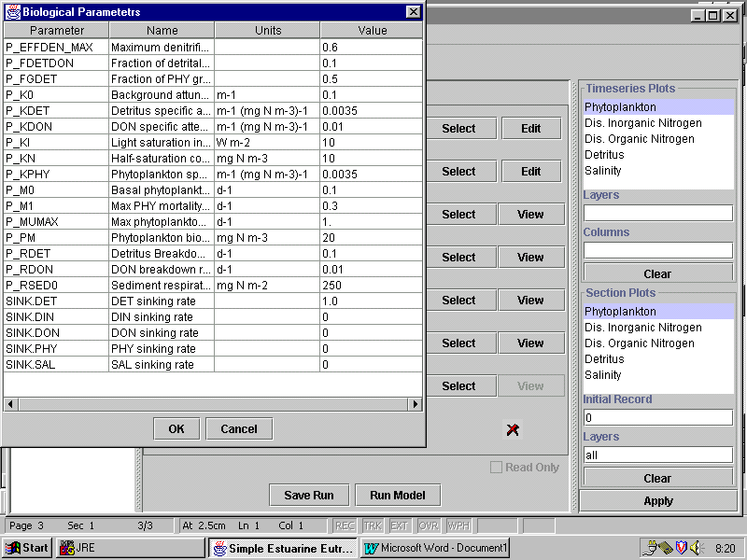
Fig. 3. User interface during editing of parameter files.

Run-Time Parameters

Fig. 4 shows the interface with the Run-Time Parameter Pane Selected. The run-time parameters are:
- output Step: ie interval at which the model state is written to the output file;
- state.start.time: This is the time used to select the starting state in the State Initialisation File, (relative to the State Initialisation File Epoch);
- model.stop: Model stopping time (relative to the model epoch);
- model.start: Model start time (relative to the model epoch);
- model.epoch: Base date and time for model times;
- model.step: Model time step.

SEEM can handle time units of seconds or days. If no units are specified, the model assumes times are in seconds.

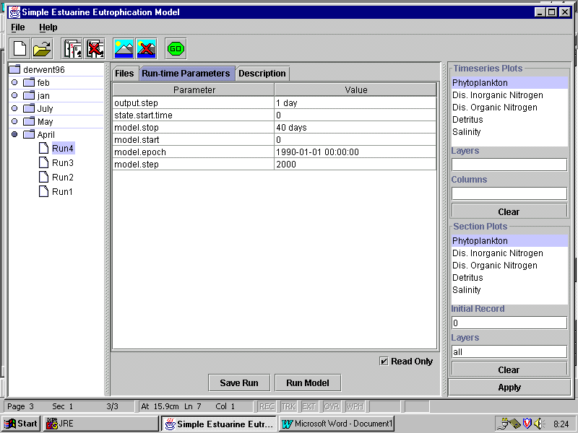
Fig. 4. User interface with Run Time Parameters pane selected.

Description.

The third Description pane is a simple text pane, which automatically contains the date and start time for each Run. The user can add any text comments, and these are recorded as part of the run history.

RUNNING THE MODEL.

Once the Run files and parameters are specified, the model run is initiated by clicking the Run Model button at the bottom of the central panel, or the “GO” button at the top left of the Interface. When the run is complete and the output file has been created, the tick appears on the Files pane next to the output file.

If the user wants to record changes in parameters and files, but not run the model, clicking the Save Run button will save the parameters and update the Biology file without running the model.

GRAPHICAL DISPLAY.

The panel on the right-hand side of the user interface allows the user to control the graphical display of output. SEEM offers two kinds of plots: plots of variables in cells over time (Timeseries Plots) and plots of variables at one time versus distance along the estuary (Section Plots).

In the case of TimeSeries Plots, the user can specify, for each variable, selected columns and layers. SEEM generates a separate plot for each variable, but plots all column and layer combinations on the same plot. The user can specify layers individually, or plot all layers by typing “all”. The user specifies columns as numbers separated by commas. Remember that columns and layers are numbered starting at zero.

In the case of Section Plots, the user specifies individual layers, or “all” layers, for each variable. SEEM generates one plot for each variable.

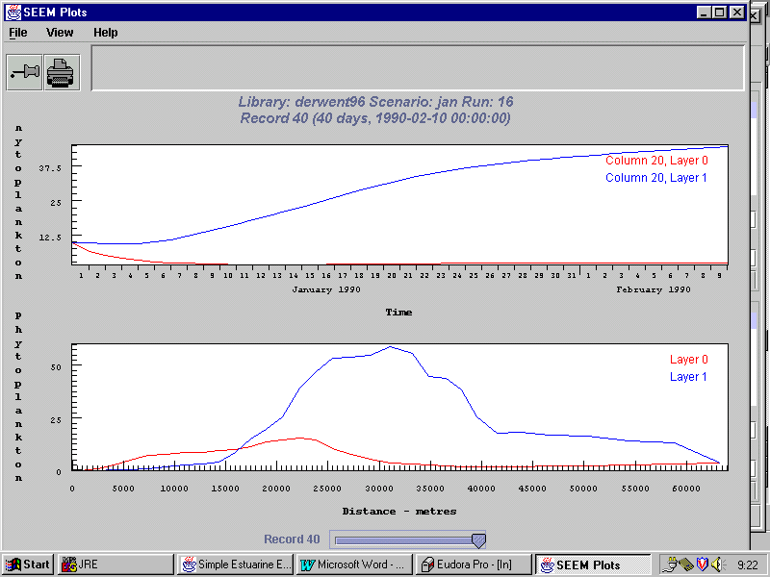

Fig. 5. SEEM Plot panel showing a time series plot and section plot.

After the plots are specified, pressing the APPLY button causes SEEM to produce a plot window (Fig. 5). SEEM automatically tiles the requested plots on one window. The tiling can be altered by clicking on the VIEW button at the top left. SEEM automatically scales vertical and horizontal axes.

The time corresponding to the section plot can be chosen interactively by moving the sliding button at the bottom of the window. The RUN and the section plot time are specified at the top of the plot window.

Clicking on the print icon in the top left of the plot window brings up a standard print control panel. The pin icon in the top left of the window allows the user to freeze the plot window. This is useful for comparing one plot window with another. If the plot window is not pinned and left open while the Run or plot specification is changed, SEEM overwrites the existing window. If the window is pinned, it is frozen in its current state, and SEEM will create another plot window if the APPLY button is clicked.

REFERENCES
Parslow, J., A. Davidson and J. Hunter. 1999. Estuarine Eutrophication Models. National River Health Program, Urban Sub-Program. Report No 12, LWRRDC Occasional Paper 19/99.

